In this lesson we will learn using multiple nodes
We will do most of the work in node graph
we will not do anythinbg in Timeline or do animation we just gonna pay with nodes aand we are gonna play with color correct nodes
So first i am gonna read a file

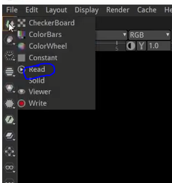
by clicking on the image node in toolbar and in dubmenu choose and then in browse window find the video or image you want to import

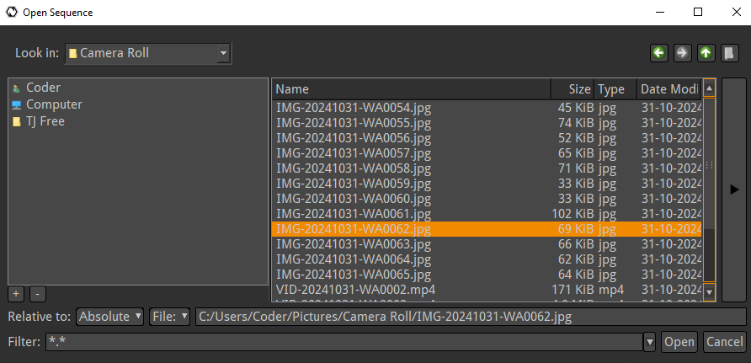

Now click the open button to make the read node and then it will be shown in node graph
If the viewer node was already selected then the read node will be by default linked to the viewer and the video or image wwill be shown in Timeline or Viewer window. But if not then you need to link it manually Before linking the Viewer window might be blank and if you link it then the video or image will be shown in

We want to make a change in this image like color change

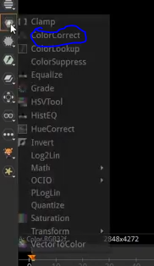
Now go to Color nodes and then to Color Correct node as marked above
Now node graph will look like below

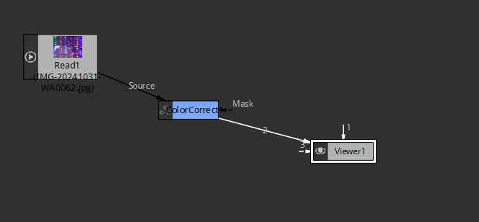

The data(image or video) go to color node and then to Viewer1 node
2:10

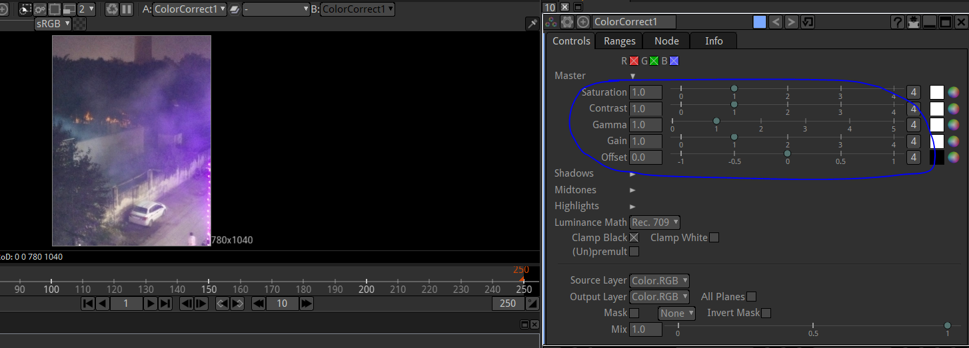
Now in properties window you can see the properties of color corrdct node
We can increase the saturation or Gamma
then its look changes

Before it was looking like below

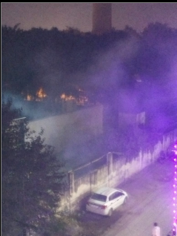
But after increasing saturation it will look like below

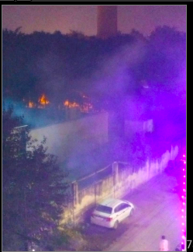
If we want to see how it was looking before aplying properties of Color effect then delete the color effect node now the Reader node is directly connected ot the viewer node as The color node was in between them
press undo to see the image after applying color Correct node and hten compoare the image after applying the colorCorrect node

The another way is that select the color aCorrect node and then Press D Now it will have an X over it as shown below

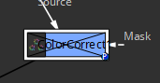

Now this node will be ignored and it will not have an effect on the viewers output
Again press D to enable it

Lets put another node here like another color correct node
Now we ad d it and it looks like below

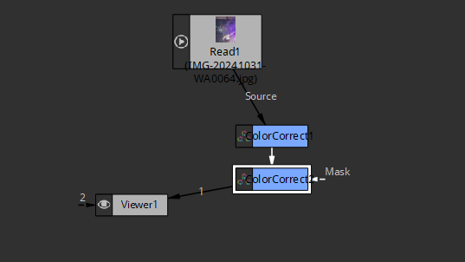
Since colorcorrect was selected before making
Note:-

I have observed that when the output of colornode1 will be input of colornode2

So for example if you make an image less saturated then that image will be input for Colorcorrect node 2

According to teacher it is redundant but we can use multiple nodes of the same type

Now we add another node that is equalizer you can add(This time we have not selected any node by clkoin on any empty space in the Node graph )
You can add it before the colorCorrect or after teh colorCorrect node and we acheive different result on the nasis of where we are at
So let us put after just for fun
So to put it betwen the nodes there is a way for that you just need to hold ctrl and then yellow dot will be shown between two connected nodes on their path
as shown below

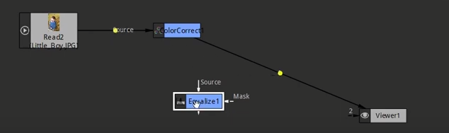
Now if we deag equalizer with holding ctrl then it will be placed between the two nodes on the yellow dot now it come between them
I place teh equliser on the yellow dot between ColorCorrect and Viewer1 node

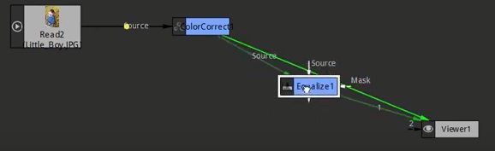
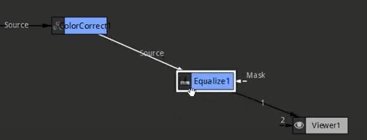
The other way is manual way that is unlink and then again link by placing the Equalizer between them

In every node you must have seen mask as maarked below
We will study about it later

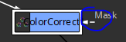
Orientation of the nodes does not matter it does not effect the final output
The placement of the node is for the people to understand the qorkflow in nodegraph

teacher like to do left to rightor Top to Bottom So he like the viewwer oin the bottom right part of the node graph and initial sources on the top left
Teacher is sating you can see the color changes
IN teacher there is no change in the image but in my project hrereis huge chaange if tune the values of teh equalizerr then brightness increases slightly

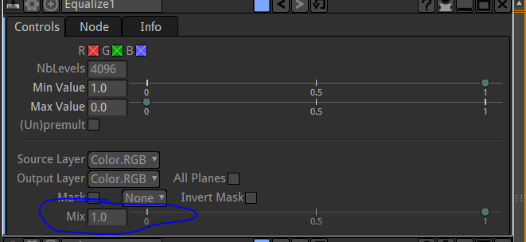
The mix property tell us how much change we want to apply to the inout we get through previous node
If ou increse it to 1 then it will bring huge change but on 0 no change will be obseerved
A lot of nodes have it at the bottom of it
like color correct

We can make it to 0.5 to apply changes as half as strong as it already have

Now we add another node that is Negative
So we select out equalizer and then click in color node menu on thetoolbar and then to invert
The invert node invert al the colors

Now node graph will look like below

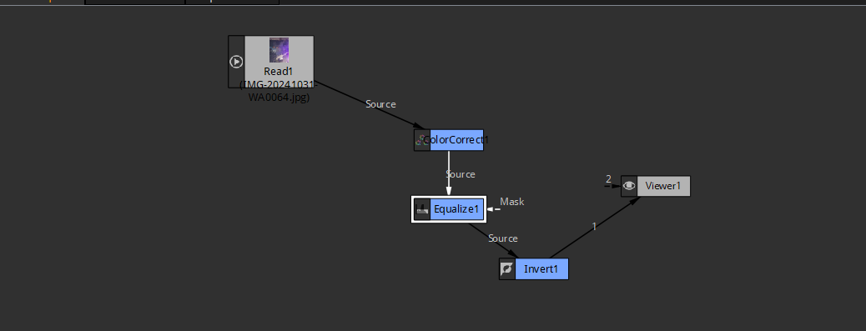

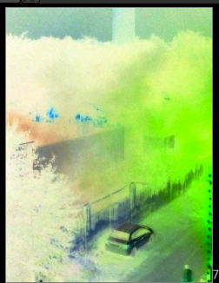
The outpur is above
So that's using multiple nodes in the next lesson we are going to look at the merge tool
and learn how you can merge if you want to bring in say a small object and a background ou can merge so thiu is anything
Everythign is here in line do far
everythign is one straight line like now
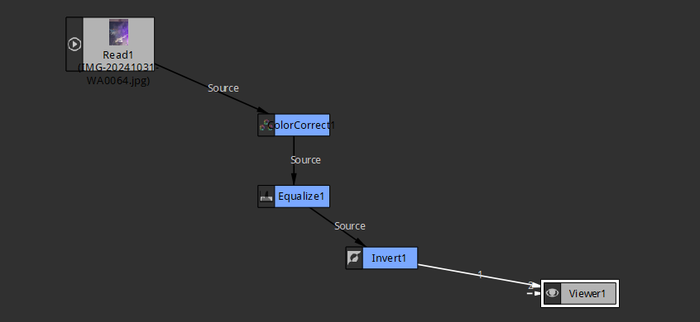
We don't have two sources trying to go in to overlap and that's what we are going to learn with the merge tool in the upcoming lesson

